Wigan Wheelers and Triathlon Club - Open 10 Miles TT L1015
Incorporating the NLTTA 10 MILES CHAMPIONSHIP EVENTS
Saturday 15th AUGUST 2020 - START SHEET
Promoted on behalf of Cycling Time Trials under their rules and regulations
** Please note due to the ongoing COVID-19 Pandemic CTT have completed an additional risk assessment on how events can be conducted. Please note this event will work differently from previously and it is vitally important you read the COVID-19 guidance in the document below. If more updates come into effect from CTT prior to the event starting I will inform you via email as soon as possible or on the day of the event.
Failure to abide by the COVID-19 risk assessment could result in suspension of CTT activities and issues with local authorities around specific courses. We ask therefore for the ongoing prosperity of the sport you follow the guidelines to the letter.
Local Lockdown regulations can result in the race being cancelled at short notice.
Event Secretary: Amanda Asbridge - 07720060021 Time Keepers: Derek Black and Tracy Moore
Headquarters: Sizergh, Nr Kendal, LA8 8DZ (Lay-By). There are no toilet facilities available
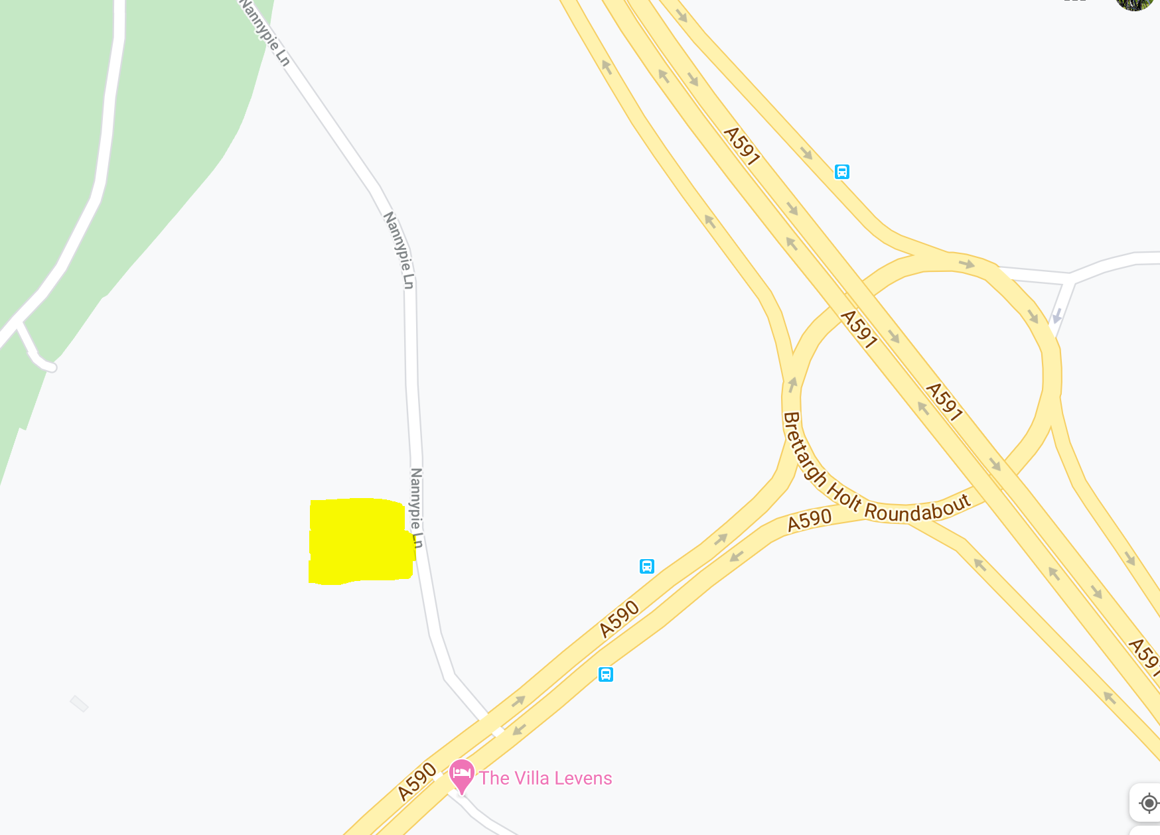
HQ opens from 17.15 First rider off 18.01
Please make every effort to start; the event was oversubscribed and to limit the number of riders hanging around I have also decided to NOT include reserves.
Please allow 10 minutes to ride to the start. From the HQ- follow the road back to the A590, turn left to the RAB encircle and ride back up the A590 to the Start (DO NOT PASS THE START YOU WILL BE DISQUALIFIED)
Number | Start Time | First name | Last name | Club | Gender | Category
1 | 18:01:00 | Sam | Kelly | East Lancashire RC | Male | Junior
2 |  | Emma | Jeffers | JRC Shutt Ridley RT | Female | Juvenile
3 |  | Sophie | Heighton | Ferryhill Whs | Female | Juvenile
4 |  | Harry | Paveley | Innovation Racing | Male | Junior
5 |  | Joe | Cosgrove | Liverpool Century Cycling Academy | Male | Juvenile
6 |  | Eve | Davies-Heywood | Sportcity Velo | Female | Junior
7 |  | Thomas | Heighton | Ferryhill Whs | Male | Junior
8 |  | Daniel | Porter | Horwich Cycling Club | Male | Juvenile
9 |  | Bryn | Lawrence | C and N Cycles RT | Male | Juvenile
10 | 18:10:00 | Joel | Ackers | Innovation Racing | Male | Junior
11 |  | Maddie | Leech | PH-MAS Cycling | Female | Junior
12 |  | Flora | Knight | Team 22 | Female | Junior
13 | 18:13:00 | Aidan | Lawrence | HMT Hospitals Giant Cycling Team | Male | Junior
14
15
16 | 18:16:00 | Sharon | Clifford | SheHair Racing Team | Male | Veteran
16 | 18:16:00 | Phil | Barnes | SheHair Racing Team | Female | Veteran
17
18 | 18:18:00 | John | Fiddies | Team Lusso | Male | Veteran
19 |  | Simon | Roddam | Wigan Whs CC | Male | Senior
20 | 18:20:00 | David | Thompson | Rock to Roll CC | Male | Veteran
21 |  | Ian | Lilley | Kent Valley RC | Male | Veteran
22 |  | Sue | Cheetham | North Lancashire Road Club | Female | Veteran
23 |  | David | Powell | Horwich Cycling Club | Male | Veteran
24 |  | Mike | Westmorland | Border City Whs CC | Male | Veteran
25 |  | Martin | Welsh | Pendle Forest CC | Male | Veteran
26 |  | Carol | Westmorland | Border City Whs CC | Female | Veteran
27 |  | Steven | Hilton | Warrington Road Club/Horton Light Engineering | Male | Veteran
28 |  | Mark | Haggart | Wigan Whs CC | Male | Veteran
29 |  | Ian | Dobbie | West Lothian Clarion | Male | Veteran
30 | 18:30:00 | Alan | Chorley | Seamons CC | Male | Veteran
31 |  | Karl | Mason | Clitheroe Bike Club | Male | Veteran
32 |  | Aiden | Heyworth | Aerobic Power Race Team (APRT) | Male | Senior
33 |  | Tom | Maher | Horwich Cycling Club | Male | Veteran
34 |  | John | Huggon | Ribble Valley C&RC | Male | Veteran
35 |  | Mark | Jones | Bury Clarion CC | Male | Veteran
36 |  | Wendy | Drake | Clitheroe Bike Club | Female | Veteran
37 |  | Simon | Horsley | Kendal Cycle Club | Male | Veteran
38 |  | Robbie | Lawton | Mersey Tri | Male | Veteran
39 |  | Tim | Lawson | Secret-training CC | Male | Veteran
40 | 18:40:00 | Henry | Moss | Barrow Central Wheelers | Male | Senior
41 |  | Richard | Mattinson | Velo Club Cumbria | Male | Veteran
42 |  | Ben | Stead | 3 RT | Male | Senior
43 |  | Thomas | Minns | Fylde coasters cycling club | Male | Senior
44 |  | James | Duffy | Bury Clarion CC | Male | Senior
45 |  | David | Ashton | Aerobic Power Race Team (APRT) | Male | Senior
46 |  | Brian | Moore | The Tricycle Association - North Western Region | Male | Veteran / Trike
47 |  | Bill | Sedgwick | VTTA North Lancs and Lakes Group | Male | Veteran
48 |  | David | Trotter | Lancaster CC | Male | Veteran
49 |  | Deborah | Moss | Team Merlin | Female | Veteran
50 | 18:50:00 | Mark | Chadwick | Wigan Whs CC | Male | Veteran
51
52
53
54
55
56
57
58 | 18:58:00 | Esther | Burt | Macclesfield Wheelers | Female | Senior
59 |  | Peter | Greenwood | Clayton Velo | Male | Veteran
60 | 19:00:00 | Danny Glyn | Roberts | Clwb Beicio Egni/Energy Cycling Club | Male | Senior
61 |  | Erica | Booth | Lancashire RC | Female | Veteran
62 |  | Paul | Drake | Clitheroe Bike Club | Male | Veteran
63 |  | Harriet | Gilson | Tri Preston | Female | Senior
64 |  | Mathew | Roberts | Clwb Beicio Egni/Energy Cycling Club | Male | Senior
65 |  | Sean | Sanders | Drighlington BC | Male | Veteran
66 |  | Richard | Tyson | Rock to Roll CC | Male | Veteran
67 |  | Patrick | Hickey | Rossendale RC | Male | Senior
68 |  | Andy | Stubbs | Barrow Central Wheelers | Male | Veteran
69 |  | Russ | Richardson | Mountain Goat Performance Cycle Coaching | Male | Veteran
70 | 19:10:00 | Andrew | Whiteside | Bella in Sella Racing | Male | Veteran
71 |  | Andrew | Barlow | Kent Valley RC | Male | Veteran
72 |  | John | Bunting | Bury Clarion CC | Male | Veteran
73 |  | Lee | Spoor | Tri Preston | Male | Veteran
74 |  | Charlotte | Boothman | Team Lusso | Female | Senior
75 |  | Alistair | Woodman | Team Swift | Male | Veteran
76 |  | Stuart | Garnett | Barrow Central Wheelers | Male | Senior
77 |  | Dave | Topping | North Lancashire Road Club | Male | Veteran
78 |  | Joanna | Cebrat | Bury Clarion CC | Female | Veteran
79 |  | Adam | Salter | Chorley Cycling Club | Male | Senior
80 | 19:20:00 | Alexander | Royle | Manchester Bicycle Club | Male | Senior
81 |  | Richard | Collins | Wigan Whs CC | Male | Veteran
82 |  | Stephen | Wilkinson | Nelson Whs CC | Male | Veteran
83 |  | Simon | Myerscough | Ribble Valley C&RC | Male | Veteran
84 |  | David | Beattie | Hawick Cycling Club | Male | Senior
85 |  | Stuart | Crawford | Chorley Cycling Club | Male | Veteran
86 |  | Tom | Gibson | Kent Valley RC | Male | Senior
87 |  | Andy | Porter | Horwich Cycling Club | Male | Veteran
88 |  | Nikola | Matthews | Halifax Imperial Wheelers | Female | Senior
89 |  | Eleanor | Turton | Seamons CC | Female | Senior
90 | 19:30:00 | Joe | Simons | Albarosa CC | Male | Senior
91 |  | Paul | Crankshaw | Wigan Whs CC | Male | Veteran
92 |  | Victoria | McMurtha | Barrow Central Wheelers | Female | Senior
93 | 19:33:00 | Mark | Berry | Rossendale RC | Male | Veteran
94
95
96
97
98
99
100 | 19:40:00 | Philip | Jones | DRAG2ZERO | Male | Senior
1* |  | Jason | Bateman | Team Bottrill | Male | Veteran
2* |  | Anna | Weaver | East Lancashire RC | Male | Senior
3* |  | John | Leach | Rossendale RC | Male | Veteran
4* |  | Jack | Millar | East Lancashire RC | Male | Espoir
5* |  | Kevin | Chadwick | Lakes Road Club | Male | Veteran
6* |  | Ben | Granger | CCCR | Male | Espoir
7* |  | David | Hill | Velo Club Cumbria | Male | Espoir
8* |  | Phil | Shaw | Kent Valley RC | Male | Veteran
9* |  | Sammie | Stuart | Crimson Orientation Marketing RT | Female | Senior
10* | 19:50:00 | Scott | Burns | Manchester Bicycle Club | Male | Senior
11* |  | David | Turner | Team4Luke | Male | Veteran
12* |  | Christina | Wiejak | Jadan CycleSpace- Vive Le Velo | Female | Senior
13* |  | Michael | White | Springfield Financial Racing Team | Male | Veteran
14* |  | Janet | Fairclough | Liverpool Phoenix CC (Aintree) | Female | Veteran
15* |  | David | Gleave | Velo Club Cumbria | Male | Senior
16* |  | Tony | Greenhalgh | Team Chronomaster | Male | Veteran
17* |  | Rebecca | Rimmington | Team Merlin | Female | Senior
18* |  | Kenneth | Brown | Velo Club Cumbria | Male | Senior
19* |  | Howard | Leach | North Lancashire Road Club | Male | Veteran
20* | 20:00:00 | Simon | Wilson | Ribble Weldtite Pro Cycling | Male | Veteran

- Note – these riders would normally wear numbers 101 – 120, due to the disposable numbers only going up to 100, then these riders will need to wear numbers 1 – 20.

Due to CTT COVID-19 Risk Assessment no results board will be displayed at HQ and complete results will only be available via the CTT website post event after verification from the timekeeper. Provisional results will be available via the clubs facebook page on the night - https://www.facebook.com/WWCCWTC
CTT Regulation 17: Signing-on & signing-out sheet
a) The competitors in all types of events must make themselves aware of any special instructions for the event and sign the official signing on sheet when collecting their number.
b) In type A events a competitor must return to the HQ either during the event or within a reasonable time after the last rider has finished the event and sign the official signing out sheet.
NEW MEASURES IN PLACE - there will be a one system to sign on and out, please BRING YOUR OWN PEN AND MASK. Numbers will now be collected from the signing on area, they will not be posted out. Disposable numbers will still be in place, please do not hand them back in when you sign out. Please BRING YOUR OWN PINS
There will be a copy of the risk assessment for viewing. This will also be on the clubs website: wiganwheelers.org.
Course: L1015 – description
START in lay-by alongside the A590 approximately 500 yards south-west of junction with southbound A6 in line with the three white marks on kerb edge which are 20 yards west of a drainage grate which is 5 yards west of the eastern end of footpath and 25 yards east of a drainage grate almost in line with the SOS telephone point. This mark is directly in line with a wooden fence post with two angled supports in the hedge and almost in line with a ‘Please take your litter home sign’. Proceed along the A590 in a south-westerly direction to encircle the roundabout on Lindale by-pass (5.243 miles). Retrace along the A590 to FINISH in line with the metal cover in northern grass verge embossed ‘Charlton Iron Works Sheffield’ which is approximately 12 yards east of large road sign on slip-road to the A6 approximately 90 yards short of Levens Bridge/Levens Village road (10 MILES).
Prize List - Seniors/Womens/Veterans
Males | 1st - £40 | Females | 1st - £40 | First Team of 3 - Mixed or men £15 each
 | 2nd - £35 |  | 2nd - £35
 | 3rd - £30 |  | 3rd - £30 | 1st Lady Vet - £20
 | 4th - £25 |  | 4th - £25 | 1st Vet on Std. - £20
 | 5th - £20 |  | 5th - £20 | 2nd Vet onStd. - £15
 | 6th - £15 |  | 6th - £15 | 3rd Vet on Std. - £10
(One rider one prize apart from team prize
Prize List - Juniors and Youth
Males | 1st - £20 | Females | 1st - £20
 | 2nd - £15 |  | 2nd - £15
 | 3rd - £10 |  | 3rd - £10

ALL eligible NLTTA winners will be contacted by NLTTA to arrange collection of Association Medals and trophies.
Please note there will be no prize presentation at the event due to the COVID-19 Risk assessment. Once we have finalised results we will reach out to you to arrange payment of prize money.
The following Local Regulations have been approved by the National Committee in accordance with
Regulation 38. Any breaches may lead to disciplinary action being taken.
Local Reg No. 5 In all events, competitors prior to starting are not permitted to ride past the finishing timekeeper during the duration of the event.
Local Reg No.6 Any competitors making a U turn in the vicinity of the start or finish will be disqualified from the event.
Local Reg No.10 Course L1015-warming up on the course is not permitted during the duration of the event.
Local Reg No. 12 – NO PARKING on the car park or on the frontage of the Strickland Arms.
Local Reg No.15 Riders must keep to the left hand side of the road except when overtaking. Failure to comply with the above may lead to disqualification. Riders must give their number at the finish and elsewhere on the course where requested.
IN ADDITION TO THE ABOVE
Riders must give their number at the finish and elsewhere on the course if requested.
Riders MUST NOT STAND in the road at the start or finish. (This constitutes obstruction and is a breach of regulations and breaches the COVID-19 risk assessment below.)
Riders must NOT ride with their heads down.
Rider Safety Helmets: All competitors under the age of 18 and/or juniors must wear a HELMET of HARD/SOFT SHELL construction that conforms to a recognised Standard (See Regulation 15). Cycling Time Trials strongly recommends ALL competitors to wear such a helmet.
Competitor Machines - Lights: CTT Regulation 14(i) – Compulsory Use of Rear Red Light
NO WORKING REAR RED LIGHT – NO START.

COVID – 19 Risk Assessment - IMPORTANT - READ CAREFULLY
General / Before the Event
- Only attend the event if you are in good health. If you are experiencing any symptoms associated with COVID-19 you must not attend
- Competitors should arrive ‘dressed to race’
- For the Junior and Juveniles that are racing - 1 member of your household is permitted to attend with you. They also need to follow the guidelines stated in this briefing. Please ask them to wear a mask in the signing on/out area. They can assist you with mechanicals and first aid issues. They cannot sign on/out for you, but should be present when you do so.

At HQ
- Competitors MUST NOT gather in anyway regardless of current guidelines in the car park, HQ area or elsewhere.
- No refreshments will be served at HQ
- Please ONLY park front bumper to rear bumper to ensure social distancing is maintained at all times. Parking is available along the road with the layby. Please ensure you park respectfully and legally.

- Please remain at your car unless preparing to ride your bike, signing in or out.
- There will be NO turbos allowed to use as warm up in the HQ Lane - nannypie Lane. Turbo training warm up elsewhere is permitted so long as you park legally and away from a residential area. There will be one exception for 1 club member as they also have a partner supporting the race and needs to leave the vehicle in the lane and may use his turbo to warm up. They will be placed away from others and the signing in/out area.
- Please bring your own pen and mask to the event to sign on - there will be a one way system in place
- Disposable numbers will be in use at the event so there is no need to return your number/sign out after the event. Please bring your own pins if required.
- On arrival please come to HQ, The start sheet will be displayed on the table and the disposable numbers laid out. Please sign on using your pen, take your number and return to your vehicle.
- Toilet facilities will be unavailable at the HQ as the required cleansing of these facilities could not be maintained.
- We encourage riders to warm up on the road. NO turbos permitted in the HQ lane of Nannypie Lane. See below for further areas to park in the area.
During The Race
- An elevated resting heart rate or exceptionally quick to react heart rate during warm up can suggest an underlying asymptomatic illness of ANY kind. You should NOT start the event (DNS) and leave immediately. Do not go to the start line if you feel this is the case and notify the organiser of your intention not to start as a result of an adverse warmup after the event via telephone.
- Competitors MUST NOT leave any personal items with the time keeper or at the signing on/out table.
- There will be no pusher-off.
- Competitors must start with one foot on the ground.
- The timekeeper will be parked at the start line. They will either be at least 2 metres out of their vehicle or they will tap on the window to get the riders attention and count down to zero on their fingers to signal the competitor to start.
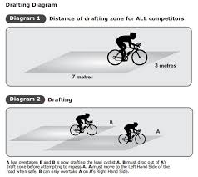
- Please arrive at the start no more than 5 minutes before your allocated start time and ensure that you line up more than two meters apart from other competitors. 2 Meters will be signalled in the layby by chalk or an alternative method. There will be a marshall based at the slip road to the A6 from the A590 to monitor the amount of riders in the layby.
- Spectators should ideally not attend unless supporting the running of the event.
- Drafting - If you should catch up another rider you should try to pass as quickly as possible and must not in any other circumstances ride close behind so that you take shelter from the wind. You must set your own pace and not use another rider as a pace maker. The onus on avoiding company riding shall be on the rider overtaken. Nor is it in order to ride alongside and even to ride a few metres behind for any appreciable distance. In the spirit of the sport, caught riders should not disturb the performance of the rider catching them by repassing and/or riding closely behind them, except when they can sustain that move. This is generally considered to mean that the caught rider should allow a reasonable gap to develop of some 30 to 50 yards/metres.
- No support can be provided if a competitor suffers mechanical difficulties. It is strongly advised that all competitors carry with them a spare inner-tube/tubular, pump and tyre levers if required.
- Support vehicles are only permitted to pass you once within 10 miles and should not follow you on the course - this is probably mainly for the Junior and Youth rider who are permitted 1 member of their household with them. Riders should also have a first aid kit in their vehicle. In an emergency marshalls will contact Amanda Asbridge to deal with the situation who will assess the situation and seek emergency help is required. Full PPE available if needed in an emergency - but only to be used by Amanda Asbridge. Marshals have been instructed not to assist - sorry.
- It is strongly advised that all competitors carry a mobile phone and take with them the telephone number of the event organiser - Amanda Asbridge 07720060021. Please telephone the organiser if you have failed to finish the event.
After the Race
- Competitors on finishing MUST NOT stop at the finish and MUST NOT loiter at the HQ/car park and MUST pack away and leave immediately upon completion of the race.
- No Results board or prize giving will be conducted on the day to ensure people do not gather at HQ. Results will be available via CTT and sent via e-mail as soon as we have collated them after the event.
This event may be subject to a Doping Control
It is your responsibility to check As soon as you have finished you should return to the event HQ as it is your responsibility to check if you are required for Doping Control Race numbers required for Doping Control will be displayed at the HQ adjacent to the result board If your number is displayed you should report immediately to Doping Control which will be nearby Remember, it is up to you to check and ensure that you comply If required you must report to Doping Control after finishing without delay.

Additional places to park

LA8 8EA
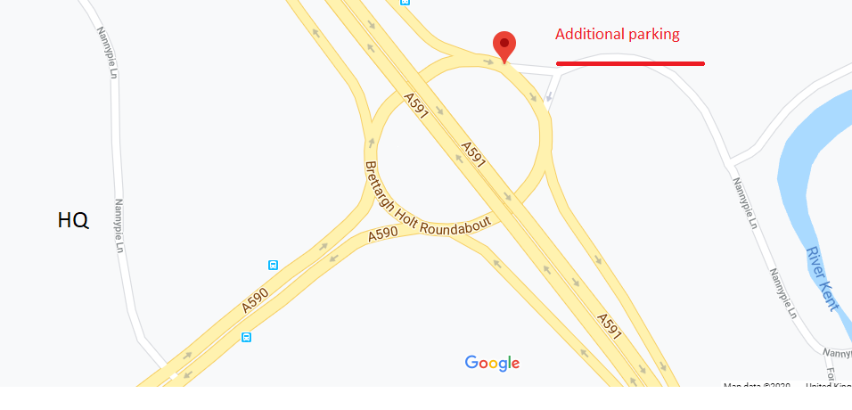

LA8 8EG
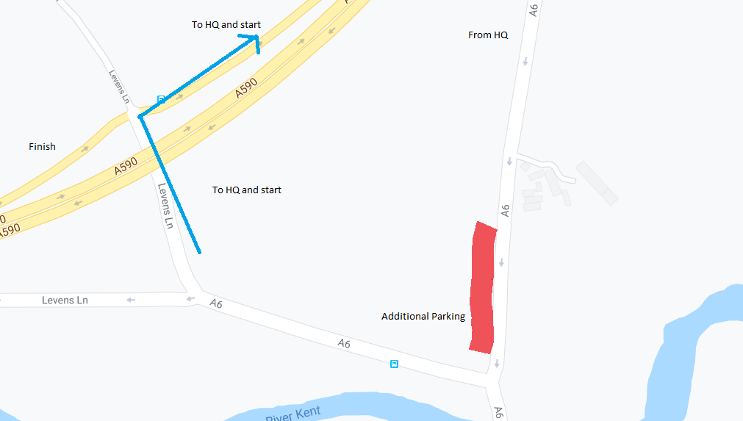

There are smaller laybys on the course A590 and the A6 and Nannypie Lane.

Please be considerate when parking and social distance at all times. Do not get changed, urinate or warm up in front of or in close proximity of any residential home.

